Contents

Technical Specifications 2
Getting to know your laptop 3
Keyboard Layout 4
Turning on your Laptop 7
Using the Touchpad 7
Charging the Laptop 10
Turning on the Laptop for the first time 10
Unlocking the display 10
Start menu 11
The Action Center 11
Activating WIFI and opening the browser 11
Reset 12
Standby 12
Shutting down 12
Saving energy 12
Taking a Full Backup of a Windows 10 on an External Hard Drive 13
Safety notices for your Laptop 13

Technical Specifications

CPU Stoney Ridge（A9 -9400/10W）
Operating system Windows 10
RAM 4GB
Storage 64G eMMC
Screen Panel 14.1” TN
Aspect Ratio 16:9
Resolution 1366*768 HD
Camera Front 0.3.M Pixels
Wireless Lan 802.11 b/g/n
Bluetooth BT 4.2
Speakers Built-in box speakers
Microphone Built in Microphone
I/O interface 1*Earphone 3.5mm
1*DC charging
1* Mini HDMI
3*standard USB Interface
1*Micro SD Socket
1*USB C Socket
Battery 7.6v 5000mAh
Keyboard Full size keys, without backlight
Touchpad Supports PTP
AC adapter 19V 2.1A
Measurement 322*208.6*21mm
Materials Plastic
Getting to know your laptop
Camera

t
Display

t
Power button

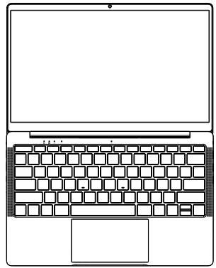
Headphone/Headset/Microphone
Micro SD Card Slot

USB port

USB port

USB port

USB C port
Power (DC) input port

HDMI

Keyboard Layout
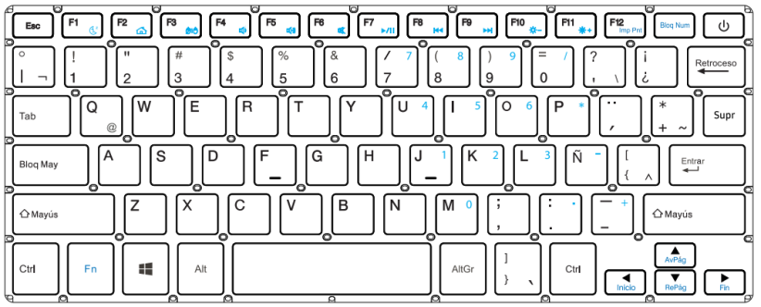

Note:The following key functions depend on the actual customer's keyboard function requirements
Key | Description
Fn Key | Execute the lock touchpad and F1-F12 keys when pressed with the said keys.
Windows Key | Open the Start Menu. Press again to close the Start Menu.
Scroll Lock Key | Press to disable scrolling with the arrows keys. Press again to disable this function.
Print Screen Key | Capture a screenshot of the entire screen.
Pause Key | Pause Continuous Output

Key | Function | Pressed with Fn
 | ESC Key | Lock TouchPad
 | Enter Sleep Mode | F1
 | Turn On/Off LCD | F2
 | Mute/UnMute | F3
 | Volume Down | F4
 | Volume Up | F5
 | Screen Brightness Down | F6
 | Screen Brightness Up | F7
 | Turn On/Off Wifi | F8

Key | Function | Pressed with Fn
 | Fast Backward | F9
 | Play / Pause | F10
 | Fast Forward | F11
 | External Display | F12
 | Up Arrow | Page up Key
 | Down Arrow | Page down Key
 | Left Arrow | Home Key
 | Right Arrow | End Key

Turning on your Laptop
USB 3.0 port

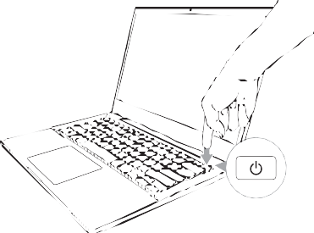
Short press the POWER button
to start your laptop

Using the Touchpad

Slide horizontally

Slide vertically

Slide diagonally

Left click

Click an app to select it.
Double click on an app to launch it.
Click to open the right-click menu.
Tap two fingers to simulate
the right-click function
Slide two fingers up or down to scroll.

Slide two fingers left or right to scroll.

Right click

Two fingers tap

Two fingers scroll (up/down)

Two fingers scroll (left/right)

Zoom out
Swipe three fingers left or right
to switch between apps.
Select an item then press and hold the left button. Using your other finger to slide on the touchpad to drag the item, release to drop.
Bring together two fingers to zoom out.

Zoom in

Spread apart your two fingers to zoom in.

Two fingers drag and drop

Three fingers swipe left/right

Three fingers swipe up

Swipe three fingers up
to open Task View.

Three fingers swipe down

Swipe three fingers down
to show desktop.

Charging the Laptop
Please charge your Laptop fully before using it for the first time.
Connect the DC plug on the supplied power adapter to the charging socket (DC IN) on the Laptop.
Then plug the power adapter into a socket.
The charging LED lights red while the device is charging.
Only leave the power adapter connected to the socket until the battery of the Laptop is fully charged.

Note: You can also purchase power adapter with Type C output to power up the laptop, but adapter is not included and adapter output should be 19V/2.1A

Turning on the Laptop for the first time
Bring the screen upwards until it is standing at a minimum angle of 90° to the keyboard.
Press and hold the Power button to switch on the Laptop. The setup assistant will then appear on the screen.
Follow the setup assistant instructions to set up your Laptop.
During the startup, the wizard prompts you to register for your Microsoft account. If you do not yet have a Microsoft account, please set one up here.
After completion of the startup, your Laptop is being configured. This process may take several minutes to complete. Do not turn the Laptop off during this time.

Unlocking the display
As soon as the device has been set up (and every time it is subsequently switched on and booted up), the lock screen appears, press any key on the keyboard to unlock the screen.
If your Laptop is password-protected, you must then enter the password.

Start menu
To display the start menu, click the Windows icon in the bottom left of the display or press the Windows button on the keyboard. Press the icon a second time to hide the Start menu.
The Start menu consists of the classic navigation list (A) and a useful app area (B) to the right of the navigation list.
Among other things, the navigation list includes a link to open Settings (cog wheel icon).In the app area, you can pin apps and favourites in the form of live tiles and organize them.
In the navigation list (A) you find a list of all installed apps in alphabetical order. An alphabetic quick access to the navigation list appears when you click on a respective first letter.

The Action Center
The Info Center is a bar with quick links to some important Laptop functions, which you can either display or hide.
To access the Info Center click the memo symbol in the bottom right-hand corner.

Activating WIFI and opening the browser
a. Call up Settings(see “Start menu”).
b. In the settings, click “Network & Internet”.
c. Click “ Wi-Fi” on the left in the next screen.
d. Click the slider or the word “Off”. The word “On” now appears next to the slider.
The Laptop searches for all available for all available wireless networks nearby and then displays them as a list (“Show available networks”).
e. Click the network that you wish to connect to.
f. Enter the network key (password) if necessary.
g. Click “Connect”. The Laptop connects to the selected network.

You can also click network icon on the task bar at the right bottom of the display to setup WIFI.
The button for launching the Internet browser can be found on the task bar at the bottom of the display. Click the little blue “e” to launch the browser. To enter an Internet address (URL), click the search bar displayed centrally at the top of the window.

Reset
If the Laptop “freezes” and no longer responds, you can reset it. Please and hold Power button for 8 seconds until the power indicator turns off. Wait for about 20 seconds and then turn on the laptop normally.
Any files that have not been saved will be lost when the Laptop is reset.

Standby
Press the Power button on the device for 3 seconds to activate the standby mode. Press it again quickly to take the Laptop out of standby mode.

Shutting down
Open the Start menu. Click“ ” in the bottom area of the Start menu and then tap “Shut down”. The Laptop shuts down.

Saving energy
Deactivate the WIFI function when it is not in use.
Always disconnect the power adapter form the Laptop when you are not charging the Laptop.
Reduce the display brightness under by pressing “ ”key.
Activate standby mode or turn off the Laptop completely if you are not using the Laptop.

Taking a Full Backup of a Windows 10 on an External Hard Drive

Step 1: Type 'Control Panel' in the search bar and then press <enter>.
Step 2: In System and Security, click "Save backup copies of your files with File History".
Step 3: Click on "System Image Backup" in the bottom left corner of the window.
Step 4: Click on the button "Create a system image".
Step 5: Choose your hard drive and click Next.
Step 6: Click "Start backup" to start the backup process.

The backup wizard could take from 10 minutes to several hours, depending on the amount of data that needs to be backed up and the speed of the hard-disk.

Safety notices for your Laptop
WARNING!
The bottom of the Laptop can get warm to hot while in use or while charging the battery pack. When working on your Laptop, do not place it on surfaces that can block the vents.

CAUTION!
This Laptop should only be used in environments with ambient temperatures between 5℃（41℉）and 35℃（95℉）.
Refer to the rating label on the bottom of your Laptop and ensure that your power adapter complies with this rating.
The power adapter may become warm to hot while in use. Do not cover the adapter and keep it away from your body while it is connected to a power source.

IMPORTANT!
Ensure that your Laptop is connected to a grounded power adapter before turning it on for the first time.
When using your Laptop on power adapter mode, the socket outlet must be near to the unit and easily accessible.
Locate the input/output rating label on your Laptop and ensure that it matches the have multiple rating output currents based on the available SKU.
Power adapter information:
-Input voltage: 100-240V
-Input frequency: 50/60 Hz
-Rating output current: 2.1A
-Rating output voltage: 19V

WARNING!
Read the following precautions for your Laptop’s battery:
Only Flipkart-authorized technicians should remove the battery inside the device (for non-removable battery only).
The battery used in this device may present a risk of fire or chemical burn if removed or disassembled.
Follow the warning labels for your personal safety.
Risk of explosion if battery is replaced by an incorrect type.
Do not dispose of in fire.
Never attempt to short-circuit your Laptop’s battery.
Never attempt to disassemble and reassemble the battery (for non-removable battery only).
Discontinue usage if leakage is found.
This battery and its components must be recycled or disposed of properly.
Keep the battery and other small components away from children.

"This Product is ROHS Compliant"
Disposal of Used Electrical & Electronic Equipment
-------------------------------------------------------------------------------------------
Packaging and electrical goods should be recycled
appropriately, and not treated as household waste. Please
dispose of this equipment at your applicable collection point for the recycling of electrical & electronic equipment waste. By ensuring the correct disposal of this product, you will help prevent potentially hazardous to the environment and to human health, which could otherwise be caused by unsuitable waste handling of this product. The recycling of materials will help conserve natural resources. Please do not therefore dispose of your old electrical and electronic equipment with your household waste. For more detailed information about recycling of this product, please contact your local city office, your household waste disposal service or the shop where you purchased the product.

Warranty Terms & Conditions
("Company") warranties the product to be free from manufacturing defects or any other specific defect as may be specified in the Specific Terms and Conditions below. The warranty is for a period mentioned in the Specific Terms and Conditions below, the invoice (if not specified in the Specific Terms and Conditions below), as well as the product listing page, and such period shall commence from the date of purchase of the product by the first end user. This is a non-transferable warranty, valid only in the territory of India and extended only to the first end user customer (“Customer”) basis the following terms and conditions, which the Customer is deemed to have accepted upon purchase of the product:
1. The warranty period of the product is 1 year, commencing from the date of purchase, Warranty service which includes replacement or repairs, will be carried out through the Authorised Service Centers (“ASC/s”) only.
2. Warranty will be valid only when the original purchase invoice is presented at the time of service. Company reserves the right to decline warranty service, if the purchase invoice is not presented.
3. In case of commercial usage of the product, warranty period would be limited to 90 days only.
4. Warranty will cover only functional parts, issues having manufacturing defects and does not cover damage to the product resulting from unauthorised adaptations/ adjustments/tampering/
repair, improper installation or placement, mishandling, improper use, deviation from the instructions set out in the user manual (if applicable) normal wear and tear caused due to the use of the product.
5. Warranty does not cover any external accessories and fittings to the product.
6. All plastic, rubber, glass, or aesthetic parts and consumable replacements will be on a chargeable basis.
7. Warranty shall not apply to damages caused to the product by accident, voltage fluctuations, lightening, ingress of water (beyond certified limits, if any), fire or any other natural calamity, improper ventilation, dropping or excessive shock, or any external cause beyond Company's control.
8. Company shall retain all products or spare parts which are replaced and the ownership of the same shall vest with the Company.
9. Company is not liable to provide repair services or spare parts after the period of warranty expires and the same if provided will be on a chargeable basis.
10. Whilst the Company, through its ASC, shall make every effort to carry out the service at the earliest, it is expressly clarified that the Company is under no obligation to do so within a certain time period.
11. Whilst Company would take all necessary steps to repair the product under warranty and maintain sufficient stock of spare parts of the products, in certain cases, at its sole discretion, Company may due to non-availability of spare parts of the product or product being in a state which is beyond economic repair, offer a replacement scheme to the Customer. The terms of such replacement offer is subject to change from year to year and shall also be applicable on the maximum retail price of the product.
12. All transportation & handling expenses incurred while replacing or repairing will be payable by the Customer.
13. For any warranty claim requested by the Customer from the region beyond municipal limits of the jurisdiction of the ASC, a visit by an authorised service personnel may be arranged by the Company through its ASC, on a case to case basis, at its sole discretion and the charges towards such visit will be borne by the Customer.
14. Warranty shall be void if:
A. The type or serial no. on the product has been altered, removed or defaced.
B. The product is not operated as per the instructions given in the User Guide, if any.
C. The defects are caused by household pets, rats, cockroaches or any other animals or insects.
15. The warranty automatically expires after the period of time stated in the product invoice even if the product may not be in use for any time for whatever reasons.
16. This Warranty shall not affect Customer's statutory rights under any applicable law
17. Customer agrees to indemnify and keep Company harmless against all damages, liabilities, costs, expenses, claims, suits and proceedings (including reasonable attorney's fee) that may be suffered by the Company as a consequence of: (i) violation of these terms and condition by the Customer; (ii) violation of applicable laws by the Customer; (iii) any action or inaction resulting in willful misconduct or negligence on the Customer's part.
18. In the event of repairs of any part(s) of the product, the Warranty will thereafter continue and remain in force only for the unexpired period of the Warranty. Moreover, the time taken for repair and in transit whether under the Warranty or otherwise shall not be excluded from the Warranty period.

19. None of the employees, sellers, dealers or ASCs of the Company have the authority to vary these terms and conditions.
20. Customer agrees that the courts at Bangalore shall have the exclusive jurisdiction to settle any dispute that may arise in relation to this Warranty or these terms and conditions.
21. COMPANY SHALL NOT BE LIABLE FOR ANY INDIRECT, SPECIAL, PUNITIVE, EXEMPLARY,
SPECULATIVE OR CONSEQUENTIAL DAMAGES, INCLUDING, BUT NOT LIMITED TO, ANY LOSS OF USE, BUSINESS INTERRUPTION, AND LOSS OF INCOME OR PROFITS, IRRESPECTIVE OF
WHETHER IT HAD AN ADVANCE NOTICE OF THE POSSIBILITY OF ANY SUCH DAMAGES.
22. For any further information / assistance please contact our customer Redressal cell at:

KEEP OUT OF REACH OF CHILDREN
Children should be supervised to ensure that they do not play with the appliance.

